**Sprint2**

**Incremental Testing and Regression Testing**

Team:Nanxin Jin, Yang Shi, Weijie Meng, Jintao Zeng, Yaoxi Liang

1. **Classification of Components**

* **Define all components**

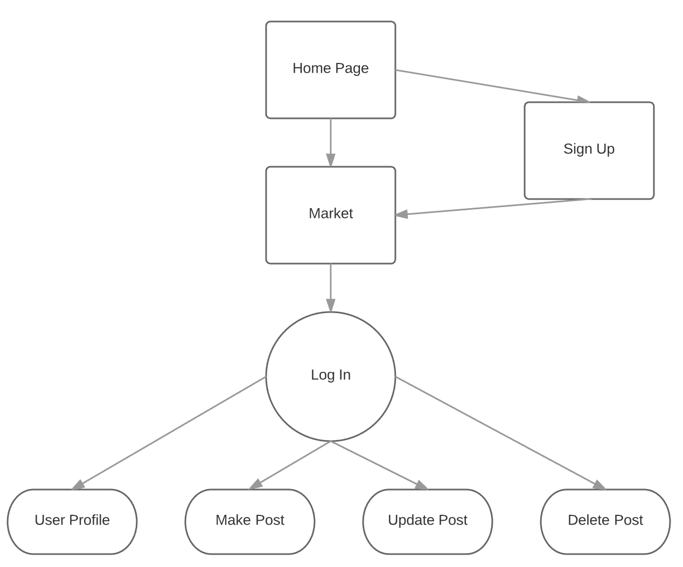

Homepage

Input:None

Output:None

Parent Dependency: None

Child Dependency:Sign up, Market

Sign Up

Input: Username,Password

Output: Success or fail message

Parent Dependency: Homepage

Child Dependency: Market Page

Market

Input:None

Output:None

Parent Dependency: Homepage, Sign up

Child Dependency: Login

Login

Input:Username, password

Output:Success or fail message

Parent Dependency: Login

Child Dependency:User Profile, Make Post, Update Post, Delete Post

User Profile:

Input: Personal info

Output: Success or fail message

Parent Dependency: Login

Child Dependency:None

Make Post:

Input: Item name, price, content

Output: Success or fail message

Parent Dependency: Login

Child Dependency:None

Update Post:

Input:Item name, price, content

Output: Success or fail message

Parent Dependency: Login

Child Dependency: None

Delete Post:

Input: Post name, item information

Output: Success or fail message

Parent Dependency: Login

Child Dependency:None

* **Which form of incremental testing did you follow**

Functional incremental testing:

Since we’ve already added most of the sub-modules of our application which can be displayed as functions, it is time we tested the functionalities of the whole project and to correct the dependencies or relations of the existing functions.

1. **Incremental and Regression Testing**

|  |  |  |  |
| --- | --- | --- | --- |
| Module | Homepage | | |
| **Incremental Testing** | | | |
| Defect # | Description | Severity | How corrected |
| 1 | When user click on the Market button the page change to the Market page without the navigation bar | 3 | Set the default UI-router to the homepage with the navigation and only replace the component when changing page |
| 2 | “See All” button can’t load the developer information | 2 | Import the service to get the information for the button component |
| **Regression Testing** | | | |
| Defect # | Description | Severity | How corrected |
| 1 | Fixing the login button issue causes page fail to send login request | 3 | Fix the login api call in app.js |
| 2 | Fixing the login button position in homepage causes the page jump to a wrong page | 2 | Correct the jump page code and move it into the api call result |

|  |  |  |  |
| --- | --- | --- | --- |
| Module | Login | | |
| **Incremental Testing** | | | |
| Defect # | Description | Severity | How corrected |
| 1 | The “remember me” selector could not work | 3 | Save the user’s email and password to the local cache every time the user information has been submitted |
| 2 | When the user uses a non-existing email the page has no response to it | 2 | Check the existence of the user email if not, pop the alert. |
| **Regression Testing** | | | |
| Defect # | Description | Severity | How corrected |
| 1 | Fixing the redirecting after login causes user stuck in the main page | 3 | Fix the link problem in main page. |
| 3 | Fixing the password encryption problem causes the password was sent to the user when there is an API call | 3 | Change the selection of API response field. |
| 4 | Fixing the server send back token problem cause front end cannot receive token | 3 | Move the token to respond header instead of body |

|  |  |  |  |
| --- | --- | --- | --- |
| Module | Make Post | | |
| **Incremental Testing** | | | |
| Defect # | Description | Severity | How corrected |
| 1 | The description is not been saved in the database | 2 | Add a longer varchar object in the database to store the description for the post |
| 2 | The post was not displayed in the market right after posting | 2 | Put the grepped information into the right component of the market |
| **Regression Testing** | | | |
| Defect # | Description | Severity | How corrected |
| 1 | Fixing the server cannot make post of market item causes market item can be posted without validation. | 1 | Correct the middleware validation for making post. |
| 2 | Fixing the server can post without user validation cause market item fail to save its created time. | 2 | Change the time type to number so that the server can store epoch time. |

|  |  |  |  |
| --- | --- | --- | --- |
| Module | Update Post | | |
| **Incremental Testing** | | | |
| Defect # | Description | Severity | How corrected |
| 1 | The updated information can not be saved in the correct place in the database | 2 | correct the update operation including the query reference to the post being updated |
| 2 | After updating the page can not go back to the user page | 3 | Set the UI-router to user page after updating the post |
| **Regression Testing** | | | |
| Defect # | Description | Severity | How corrected |
| 1 | Fixing the updating post problem causes the response contains unsaved market item. | 2 | Respond the updated item instead of the old item. |
| 2 | Fixing the update post problem causes the server fail to update the object’s updateAt property. | 3 | Implement the mongoose updated plug in in mongoose schema. |

|  |  |  |  |
| --- | --- | --- | --- |
| Module | Delete Post | | |
| **Incremental Testing** | | | |
| Defect # | Description | Severity | How corrected |
| 1 | The deleted post was still remaining in the database | 2 | The server should implement the query to delete the specific entry |
| 2 | The item that was deleted in the user profile still can be found by other user in the market | 2 | Do the synchronization work on the server and controller to change the existence of the item in every places it was used |
| **Regression Testing** | | | |
| Defect # | Description | Severity | How corrected |
| 1 | Fixing the server cannot receive deleting item from client causes a user’s market item can be deleted anyone with API. | 2 | Implement middleware in API. |
| 2 | Fixing deleting item function in server causes the server always receive error status. | 3 | Correct the response status in response condition. |